Working with ParseUsers

By: Kyle Martinez, Bradley Zarek, Amar Maharaj

# About

In this tutorial we will be developing a basic Android application capable of managing user accounts stored within a Parse class table. Note that this tutorial will not stress efficiency or best practices, rather, the goal is to give you an understanding of the following:

* ParseUsers
* ParseExceptions

That being said, let’s get started!

# Importing the Parse Library

Before we can start creating ParseUsers, we must first define the ParseUser data type in our project. To do this we must download the Parse library from [here](http://parse-android.s3.amazonaws.com/2e2b3a65233bd0753e9c53d10693336a/Parse-1.5.1.zip). The library should be compressed as a .zip folder. To decompress the zipped library, simply:

1. Right-click on the zipped library folder
2. Select Extract all…
3. Click Extract

Now that we’ve gotten that out of the way, let’s actually import the library into our project (if you have not created one, now is the time)! To do this simply:

1. Navigate to Project > Properties > Java Build Path > Libraries > Add External JARs…
2. Select the Parse-#.#.#.jar file located in the folder we extracted earlier
3. Click Open
4. If everything went successfully, click the small arrow next to the Parse-#.#.#.jar located under the Libraries tab in your project’s properties panel
5. Select Javadoc location, then click on Edit…
6. Click Browse
7. Select the Parse-#.#.#-javadoc folder located in the folder we extracted earlier
8. Click OK
9. Click OK, again
10. Click OK, once more

Sweet! At this point the Parse library should be all ready to go. Note that the Parse library is only available to your current project. You will need to import the Parse library again if you wish to use it in another project.

# Creating a ParseUser

Now we will create a new ParseUser. To do this we will first need to declare and initialize a ParseUser object:

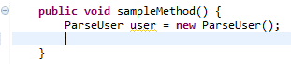

Now we can manipulate our object through its public methods! Let’s set the ParseUser’s name, password, and email:

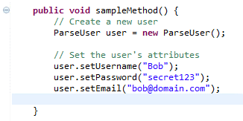

Well that was easy. Something you may want to additionally look into are ACLs, however, this tutorial will not cover them.

# Signing Up a ParseUser

Having a user stored temporarily in memory isn’t all that helpful to us, now is it? In this next part we’ll save Bob’s information to the cloud by signing him up!

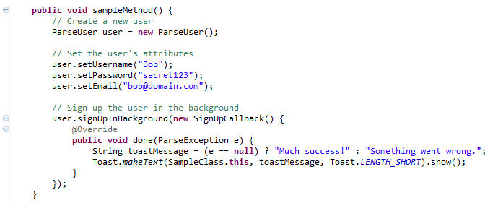

Now before you freak out, let’s break down what I just did:

* I used the user object’s signUpInBackground(…) method to indicate that I want to create and store the ParseUser’s information to the Parse server.
* Next I created a new SignUpCallback, overriding its done(…) method so that Bob will alerted as to whether the sign up process completed successfully or failed. You can read more about anonymous classes [here](http://docs.oracle.com/javase/tutorial/java/javaOO/anonymousclasses.html).
* Whether an error has occurred or not is determined by what the variable e references. If variable e has no references (i.e. it is null) then no errors have occurred. However, if variable e is not null, then an error has occurred. You can read more about the ternary operator [here](http://docs.oracle.com/javase/tutorial/java/nutsandbolts/op2.html).

Check it out! Bob’s data is now available in Parse.com’s data browser:

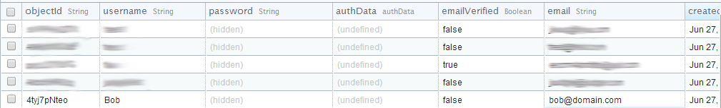

# Logging in a ParseUser

Now what if you want to allow Bob to log back into your application? No problem! Using the ParseUser class’s static logInInBackground(…) method we can have Bob, for example, log back into his account:

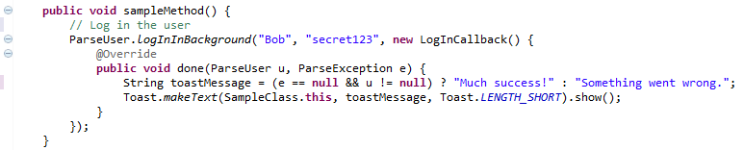

Now wasn’t that was easy? To reference the currently logged in user, use the following line of code:



# Reference Material

Here are some informative links to better help you incorporate the Parse library into your Android applications:

* <https://parse.com/docs/android/api/>
* <https://parse.com/tutorials/get-started-with-android>
* <https://parse.com/questions/should-developers-call-parseinitialize-in-oncreate-of-every-activity-android>
* <http://parse.com/docs/dotnet/api/html/T_Parse_ParseException_ErrorCode.htm>